**VIVEKANAND EDUCATION SOCIETY’S INSTITUTE OF TECHNOLOGY**

**Department of Computer Engineering**



Project Report on

**Attendance Recognition System using Half Face Appearance**

In partial fulfillment of the Third Year, Bachelor of Engineering (B.E.) Degree in Computer Engineering at the University of Mumbai Academic Year 2019-2020.

**Submitted by**

Yogesh Tekwani

Sagar Sidhwa

Somesh Tiwari

**Project Mentor**

Mrs. Mannat Doultani

(2019-2020)

**VIVEKANAND EDUCATION SOCIETY’S INSTITUTE OF TECHNOLOGY**

**Department of Computer Engineering**



**Certificate**

This is to certify that ***Yogesh Tekwani, Sagar Sidhwa, Somesh Tiwari*** of Third Year Computer Engineering studying under the University of Mumbai have satisfactorily completed the mini project on “***Attendance Recognition System Using Half Face Appearance***” as a part of their coursework of Mini Project for Semester-VI under the guidance of their mentor ***Prof. Mannat Doultani*** in the year 2019-2020.

This mini project report entitled  ***Attendance Recognition System Using Half Face Appearance*** by ***Yogesh Tekwani, Sagar Sidhwa, Somesh Tiwari*** is approved for the degree in **Computer Engineering.**

|  |  |
| --- | --- |
| Programme Outcomes | Grade |
| PO1,PO2,PO3,PO4,PO5,PO6,PO7,PO8,PO9,PO10, PO11, PO12  PSO1, PSO2 |  |

Date:

Project Guide: Internal and External

------------------------------------------

**Mini Project Report Approval**

**For**

**T. E (Computer Engineering)**

This mini project report entitled “***Attendance Recognition System Using Half Face Appearance***” by ***Yogesh Tekwani, Sagar Sidhwa, Somesh Tiwari*** is approved for the degree of T.E. Computer Engineering.

Internal Examiner

---------------------------------------------

External Examiner

---------------------------------------------

Head of the Department

-----------------------------------------------

Principal

-----------------------------------------------

Date:

Place:

**Declaration**

We declare that this written submission represents our ideas in our own words and where others' ideas or words have been included, we have adequately cited and referenced the original sources. We also declare that we have adhered to all principles of academic honesty and integrity and have not misrepresented or fabricated or falsified any idea/data/fact/source in our submission. We understand that any violation of the above will be cause for disciplinary action by the Institute and can also evoke penal action from the sources which have thus not been properly cited or from whom proper permission has not been taken when needed.

|  |  |
| --- | --- |
| -----------------------------------------  (Signature)  -----------------------------------------  Yogesh Tekwani (D12A-68) | -----------------------------------------  (Signature)  -----------------------------------------  Sagar Sidhwa (D12A-62) |
| -----------------------------------------  (Signature)  -----------------------------------------  Somesh Tiwari (D12A-71) |  |

Date:

**ACKNOWLEDGEMENT**

We are thankful to our college Vivekanand Education Society’s Institute of Technology for considering our project and extending help at all stages needed during our work of collecting information regarding the project.

It gives us immense pleasure to express our deep and sincere gratitude to Assistant Professor **Mrs. Mannat Doultani** (Project Guide) for her kind help and valuable advice during the development of project synopsis and for her guidance and suggestions.

We are deeply indebted to Head of the Computer Department **Dr.(Mrs.) Nupur Giri** and our Principal **Dr. (Mrs.) J.M. Nair** for giving us this valuable opportunity to do this project.

We express our hearty thanks to them for their assistance without which it would have been difficult in finishing this project synopsis and project review successfully.

We convey our deep sense of gratitude to all teaching and non-teaching staff for their constant encouragement, support and selfless help throughout the project work. It is great pleasure to acknowledge the help and suggestion, which we received from the Department of Computer Engineering.

We wish to express our profound thanks to all those who helped us in gathering information about the project. Our families too have provided moral support and encouragement at several times.

**Computer Engineering Department**

**COURSE OUTCOMES FOR T.E Mini Project**

Learners will be to,

|  |  |
| --- | --- |
| **Course Outcome** | **Description of the Course Outcome** |
| CO 1 | Able to apply the relevant engineering concepts, knowledge and skills towards the project. |
| CO2 | Able to identify, formulate and interpret the various relevant research papers and to determine the problem. |
| CO 3 | Able to apply the engineering concepts towards designing solutions for the problem. |
| CO 4 | Able to interpret the data and datasets to be utilized. |
| CO 5 | Able to create, select and apply appropriate technologies, techniques, resources and tools for the project. |
| CO 6 | Able to apply ethical, professional policies and principles towards societal, environmental, safety and cultural benefit. |
| CO 7 | Able to function effectively as an individual, and as a member of a team, allocating roles with clear lines of responsibility and accountability. |
| CO 8 | Able to write effective reports, design documents and make effective presentations. |
| CO 9 | Able to apply engineering and management principles to the project as a team member. |
| CO 10 | Able to apply the project domain knowledge to sharpen one’s competency. |
| CO 11 | Able to develop professional, presentational, balanced and structured approach towards project development. |
| CO 12 | Able to adopt skills, languages, environment and platforms for creating innovative solutions for the project. |

**Abstract**

Face recognition is an important application of Image processing owing to its use in many fields. Identification of individuals in an organization for the purpose of attendance is one such application of face recognition. Maintenance and monitoring of attendance records plays a vital role in the analysis of performance of any organization. The purpose of developing attendance management systems is to computerize the traditional way of taking attendance. Automated Attendance Management System performs the daily activities of attendance marking and analysis with reduced human intervention. The prevalent techniques and methodologies for detecting and recognizing faces fail to overcome issues such as scaling, pose, illumination, variations, rotation, and occlusions. The proposed system aims to overcome the pitfalls of the existing systems and provides features such as detection of faces, extraction of the features, detection of extracted features, and analysis of students' attendance.

In our face recognition project, a computer system will be able to find and recognize human faces fast and precisely in images or videos that are being captured through a surveillance camera. Numerous algorithms and techniques have been developed for improving the performance of face recognition but the concept to be implemented here is Deep Learning. It helps in conversion of the frames of the video into images so that the face of the student can be easily detected and then recognized for their attendance so that the attendance database can be easily reflected automatically.It also helps in increasing the accuracy to ultimately achieve High-Precision Real-Time attendance to meet the need for Automatic classroom evaluation. Keywords: Face recognition, Face detection, Deep Learning.

**Index**

**Title Page no**

**Chapter 1: Introduction…………………………………………….12**

1.1 Introduction to the project………………………………………...12

1.2 Motivation………………………………………………………...12

1.3 Problem Definition………………………………………………..12

1.4 Relevance of the Project…………………………………………..13

1.5 Methodology used………………………………………………...13

**Chapter 2: Literature Survey** ………………………………………15

2.1 Journal Papers or books / Book Chapters…………………………15

2.2. Inference drawn…………………………………………………..17

2.3 Comparison with the existing system……………………………..18

**Chapter 3: Requirements**……………………………………………19

3.1 Functional Requirements………………………………………….19

3.2 Non-Functional Requirements…………………………………….19

3.3 Constraints………………………………………………………...20

3.4 Hardware & Software Requirements……………………………...20

3.5 System Block Diagram……………………………………………21

**Chapter 4: Proposed Design**…………………………………………22

4.1 System Design / Conceptual Design (Architectural)………………22

4.2 Detailed Design (DFD, Flowchart, State Transition Diagram)…….23

4.3 Project Scheduling & Tracking using Timeline / Gantt Chart…….25

**Chapter 5: Implementation**………………………………………….26

5.1. Methodology applied……………………………………………...26

5.2. Algorithms implemented………………………………………….26

5.3 Datasets source and utilization…………………………………….29

5.4. Screenshots (GUI) of the project………………………………….32

**Chapter 6: Testing**…………………………………………………….35

6.1. Definition of Test Case……………………………………………35

6.2. Types of Test Cases ………………………………………………35

6.3. Test Cases…………………………………………………………38

6.4. Test Results……………………………………………….……….40

**Chapter 7: Result Analysis**…………………………………………..41

7.1.Evaluation measures ………………………………………………41

7.2 Input Parameters considered……………………………………….41

7.3 Comparison of results with existing systems ……………………...41

**Chapter 8: Conclusion**……………………………………………….43

8.1 Limitations………………………………………………………….43

8.2 Conclusion………………………………………………………….43

8.3 Future Scope………………………………………………………..43

**References (papers + books + Patent)**……………………………….44

**Appendix** ……………………………………………………………..46

1. **Progress Review Sheet 1**………………………………………46
2. **Competition Certificate (Avishkar)**…………………………..47-49
3. **Research Grant Certificate (by VESIT)**..................................50

**Table of Figures**

|  |  |  |
| --- | --- | --- |
| **Sr No.** | **Title** | **Pg.no** |
| 1 | Eigenfaces for recognition | 15 |
| 2 | Face recognition technique | 16 |
| **3** | Fast face recognition using eigenfaces | 17 |
| **4** | System Block Diagram | 21 |
| **5** | Conceptual Design | 22 |
| **6** | Flowchart | 23 |
| **7** | Task Usage Of Project | 25 |
| **8** | Gantt Chart | 25 |
| **9** | Facial Points Detection | 26 |
| **10** | dataset 1 | 30 |
| **11** | dataset 2 | 31 |
| **12** | dataset 3 | 31 |
| **13** | Attendance By Image Upload Page: | 32 |
| **14** | Image Details Page: | 32 |
| **15** | Image Details of Students Present Page: | 33 |
| **16** | Attendance By Video Upload Page: | 33 |
| **17** | Video Details Page: | 34 |
| **18** | Video Details of Students Present Page | 34 |
| **19** | Recognized Image-1 | 38 |
| **20** | Recognized Image-2 | 39 |
| **21** | Recognized Image-3 | 39 |
| **22** | Case1 Attendendance Sheet 1 | 40 |
| **23** | Case2 Attendendance Sheet 2 | 40 |

**Chapter 1: INTRODUCTION**

**1.1 Introduction to the project**

* Automatic face recognition technologies have made immense improvements in the changing world.
* The objective is to propose a system to capture the face of each student and to store it in the database for their attendance.
* There is no need for the teacher to manually take attendance in the class. because the system is provided with the image/Video by the teacher and through further processing steps the faces are being recognized and the attendance database is updated accordingly.
* A Real-Time attendance to meet the need for Automatic classroom evaluation.

**1.2 Motivation**

Nowadays mostly in every institute, industries aur companies the process of attendance is manual, that is every student , teachers , employees etc. have to give proof of their presence by signing in register or students attendance is taken by faculty by roll call.So this process of attendance takes time. Time is very valuable so we decided to make a system that takes attendance on its own without any human inclusion.

**1.3 Problem Definition**

This project aims to capture the photo or video of the students, convert it into frames, relate it with the database to ensure their presence or absence, mark attendance with a timestamp for the particular student to maintain the record.

**1.4 Relevance of the Project**

* This project helps to recognize the face of people .
* This recognition process will help to minimize the possibility of errors occurring during the manual process.
* This process also provides a valid and transparent proof.
* The dataset contains the photos of the people so that after the process of complete detection of face for recognition it can refer to the dataset.
* To increase the feature matching process of faces for recognition we have done the feature extraction part explicitly and saved the time.
* At the end , the system can take the video or the photo of the person so as to mark the attendance successfully and to generate the attendance sheet with a timestamp.

**1.5 Methodology Used**

* **Capturing points on faces:**

Facial Points are being captured from the image using face_recognition algorithm in python.

* **Facial feature Extraction:**

The extractions of some facial features like points of the difference between the eyes, width of nose, mouth and the length of the chin from the known and Captured images.

* **Generation of Encodings:**

Generations of the encodings from the images present in the database and saving the encodings in to the pickle file this is because we are extracting the images encodings in the form of dictionary having the key as the name of the image for which the encodings are to be generated and the values as the list which contains the encodings of the each images.

* **Comparison:**

The eocodings of the extracted images and the images which are presented in the database are compared and if the encodings match with the images in the database and the input frame then the student is recognized.else remains unknown.

* **Generate Attendance:**

After the student is successfully recognized from the results of encodings which are successfully compared from the known faces encodings are further processed to the marking of the attendance of the student present

**Chapter 2: LITERATURE SURVEY**

**2.1 Journal Papers or books / Book Chapters**

For our project we got motivation by the research carried out by the following people and their published papers:

**1] “Eigenfaces for recognition’’ (Mathew Turk and Alex Pentland)**:

**Abstract:** Here they have developed a near-real time computer system that can locate and track a subject’s head, and then recognize the person by comparing characteristics of the face to those of known individuals. The computational approach taken in this system is motivated by both physiology and information theory, as well as by the practical requirements of near-real time performance and accuracy.

**Inference:** This approach treats the face recognition problem as an intrinsically two-dimensional recognition problem rather than requiring recovery of three-dimensional geometry, taking advantage of the fact that these faces are normally upright and thus may be described by a small set of two-dimensional characteristic views.

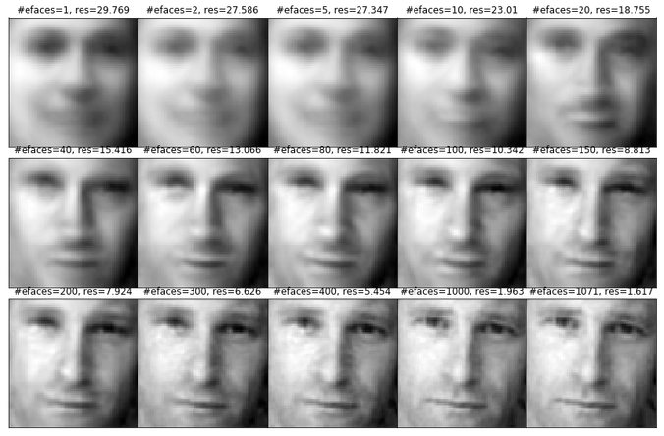

Fig-2.1.1-Eigenfaces for recognition

**2] Samuel Lukas, Aditya Rama Mitra, Ririn Ikana Desanti, Dion Krisnadi, "Student Attendance System in Classroom Using Face Recognition Technique", Conference Paper DOI: 10.1109/ICTC.2016.7763360, Oct 2016:**

**Abstract:** In this Systemthey proposes a method for student attendance system in classroom using face recognition technique by combining Discrete Wavelet Transforms (DWT) and Discrete Cosine Transform (DCT) to extract the features of student’s face which is followed by applying Radial Basis Function (RBF) for classifying the facial objects.

**Inference:** Here the process is completed actually by performing grayscale normalization, histogram equalization, Discrete Wavelet Transform (DWT), and Discrete Cosine Transform (DCT).

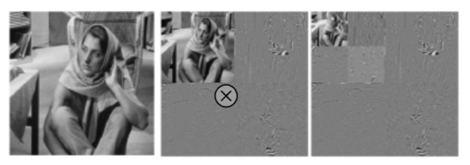

Fig-2.1.3**-**Face recognition Technique

**3] “Face recognition using Artificial neural networks” (Mayank Agarwal, Nikunj Jain, Mr. Manish Kumar and Himanshu Agrawal) :**

**Abstract:** In this they presented a methodology for face recognition based on information theory approach of coding and decoding the face image. Proposed methodology is connection of two stages – Feature extraction using principal component analysis and recognition using the feed forward back propagation Neural Network.

**Inference:** In this Recognition is performed by projecting a new image into the subspace spanned by the characteristic feature images and then classifying the face by comparing its position in the face space with the positions of the known individuals.

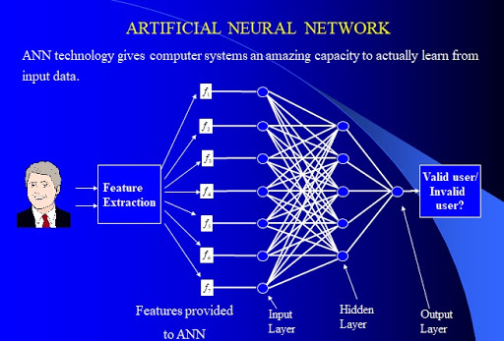

Fig-2.1.4**-**Fast face recognition using eigenfaces

**2.2 Inference drawn**

The face recognition based attendance management system was not used for institutes so here we proposed this system so that from now students and faculties get little more time for studies and teachers can teach a little more since a single knowledge a day makes a lot difference in year when it's integrated.The very important and main features we can say that it's gives the transparency and the proof will be there for longer time so that their can be no issue regarding attendance of any student.

**2.3 Comparison with the existing system**

|  |  |  |  |
| --- | --- | --- | --- |
| **Sr no** | **Characteristics** | **Existing System** | **Our System** |
| 1. | Camera(e.g External/ Laptop/ Mobile) | An external camera is used | Inbuilt System Camera is used |
| 2. | Raspberry Pi | Since an external hardware i.e Raspberry Pi is used which can be malfunctioned or Fail any time | No such hardware is used so no failure or malfunctioning of the system will occur. |
| 3 | Wires | An Jumping wires are used which will cause the hardware issues | No wires are used since we have developed a website. |
| 4. | Connectivity | Continuous Electrical, Internet Connectivity | Only Internet Connectivity is required |
| 5. | Speed | Slower due to the external hardware | Faster since no hardware is used |
| 6. | Storage | Files are Stored in hard disk (limited storage capacity) | Files are stored in server  (more storage capacity) |
| 7. | Face Points | No facial points are used since it is implemented on grey scale images | Facial points and encodings are generated. |
| 8. | Availability | Only when Connection will be provided it will available | 24x7 Availability |
| 9. | Accuracy | Accuracy is nearly 65% | more than existing system(85%) |
| 10. | Security | Less Secured since any one can access it. | More Secure since each user is having an authentication id and password |

**Chapter 3: REQUIREMENT**

**3.1 Functional Requirements**

* Facial data of people ranging from a various ethnic groups , sex will be used as a base.
* Identifying the facial texture and points using Face Recognition algorithm (Face Recognition Library using [dlib](http://dlib.net/)’s state-of-the-art face recognition built with deep learning.)
* Different gender & ethnic groups can have different data for the features of the face So these groups will be taken into consideration for recognition
* Images to be uploaded to database should be 700(length)x700(Breadth) and Size <=600kb
* Internet Connectivity should be required .

**3.2 Non- Functional Requirements**

* User friendly UI to upload the user images and test on various image samples of the user.
* Database to store the previous uploaded images of the user.
* User Login to view user specific data and various user statistics present in the Website
* Security and password for each user account to safeguard his privacy and security .

**3.3 Constraints**

* Currently, we have designed a system that detects the presence of a person by using Real-Time Face Recognition from a Real-Time Camera (eg: CCTV). But the accuracy levels are still struggling to reach the crest.
* Also, we are strategizing to detect and store the Anonymous faces separately as well for further evaluations.

**3.4 Hardware and Software Requirements**

**3.4.1 Hardware Requirements**

A standalone computer needs to be installed in the office room where the system is to be deployed. Camera must be positioned in the office room to obtain the snapshots. Optimum Resolution: 512 by 512 pixels. Secondary memory to store all the images and database

**3.4.2 Software requirements**

* Anaconda(version3)
* Dlib(19.19.0)
* Visual Studio
* Jupyter

**Tools :**

* Cmake(3.17.0)
* VC++
* Windows 10 SDK
* OpenCV

**3.5 System Block Diagram**

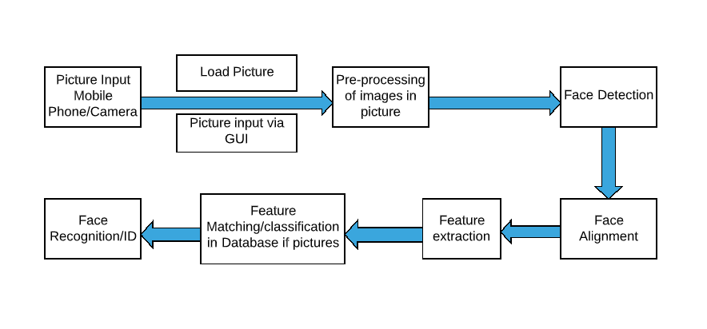

Figure 3.6.1 System Block Diagram

The System Block Diagram-Fig 3.6.1 is to capture the face of each student and to store it in the database for their attendance. The face of the student needs to be captured in such a manner that all the features of the students' face needs to be detected, even the seating and the posture of the student need to be recognized. There is no need for the teacher to manually take attendance in the class because the system records a video and through further processing steps the face is being recognized and the attendance database is updated.

**Chapter 4: PROPOSED DESIGN**

**4.1 Conceptual Design**

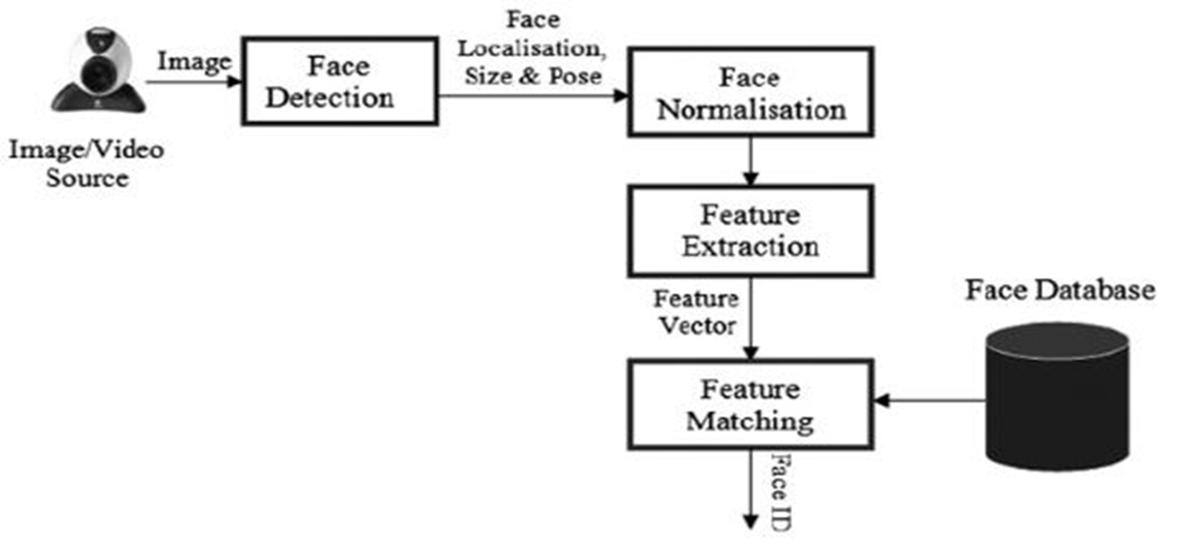

Figure 4.1.1 Conceptual Design

Steps For Implementation Of Face Recognition:

1. **Finding all the Faces:** The first step in our pipeline is face detection
2. **Posing and Projecting Faces:** we isolated the faces in our image.
3. **Encoding Faces:** Generating the Encodings for Each image in Database and Saving it for further Operations.
4. **Encoding our Input face image:** Generating Encoings for the input Image.
5. **Match the Encodings:** Comparing the Encodings of the known with respect to unknown.
6. **Finding the person’s name from the encoding:** Finally Recognized images are marked as present.

**4.2 Detailed Design**

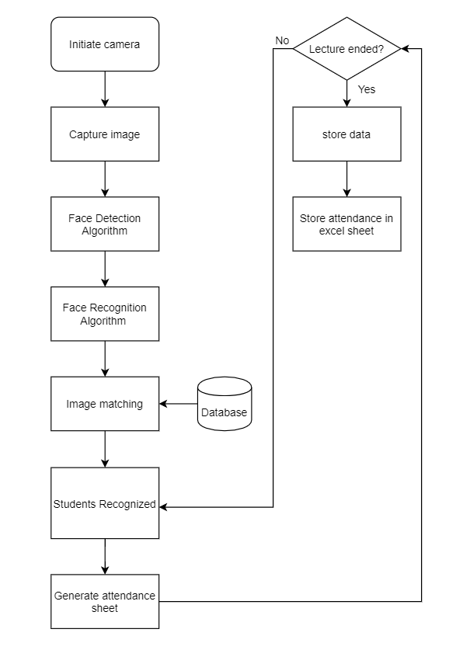

Figure 4.2.1 Flowchart

The working of the Fig-4.2.1-Flowchart is implemented as follows:

The images of the students in the Classroom are to be Captured by the mobile camera,the image to be captured should be uploaded to the website.

The next step of working is to extract the encodings from the images present in the database and saving the **encodings** in to the **pickle file** this is because we are extracting the images encodings in the form of dictionary having the key as the name of the image for which the encodings are to be generated and the values as the list which contains the encodings of the each images.

After the generation of the encodings the next step is to take the image or the video of the students then give the images or the video into the system as the input to our system and convert the input into frames. Each frame has an input to the system,then our algorithm works in different steps the very first step is to extract the images from the given input image i.e is to detect the images present in the frames.

The next step is to generate the encodings of the images which are extracted or detected the third part is to compare the eocodings of the extracted images and the images which are presented in the database and if the encodings match with the images in the database and the input frame then the student is recognized.

After the student is successfully recognized from the Face Detection and Face Recognition,encodings which are successfully compared from the known faces encodings are further processed to the marking of the attendance of the student.In this step to mark the attendance of the student which is present in the input image or frame of video.

The excel sheet is generated where the name of the excel sheet is the date and the timestamp of the image when the system is computed the processing of the input so that the actual proof which verifies that the date and time of the attendance. Also the excel sheet contains the name, date, time and present columns which have the rows of the student that are present in the classroom.

**4.3 Project Scheduling & Tracking using Timeline / Gantt Chart**

**1.Table**

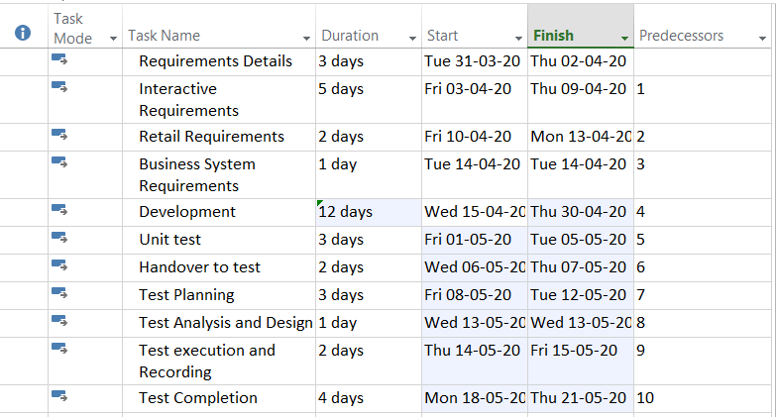

Figure 4.3.1 Task Usage Of Project

**2. Gantt Chart**

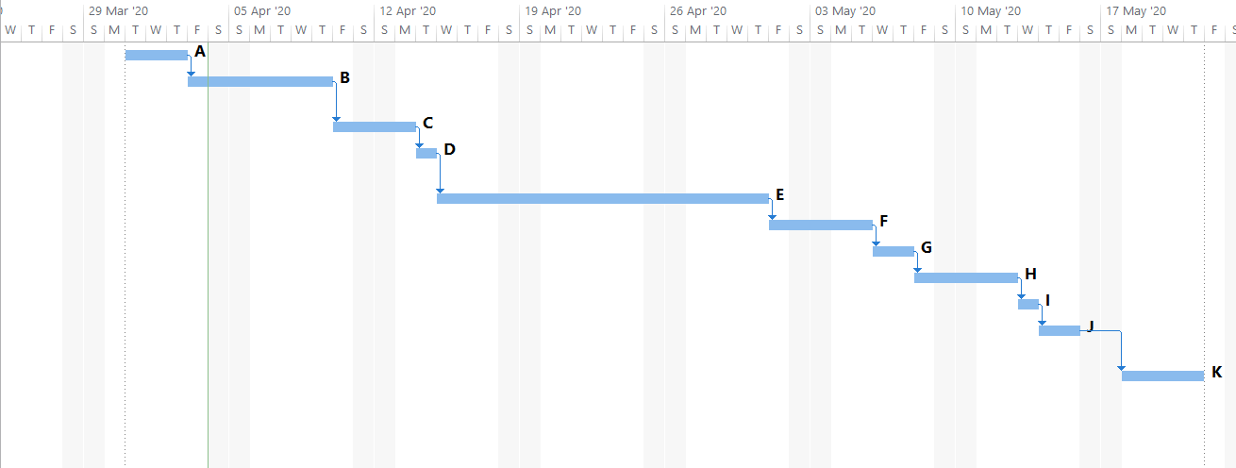

Figure 4.3.2 Gantt Chart

**Chapter 5: IMPLEMENTATION**

**5.1. Methodology Applied**

The methodology applied for the implementation of the proposed system consists of the following 5 steps:

●Collecting and storing image data with valid image_name

●Feature extraction from collected data

●take frame from image or video

●Matching the Features

●Generating attendance sheet

**5.2. Algorithms Implemented**

The **facial recognition System** is the best system which is used for first detection and recognizes whether the person is there or not by finding the faces from the given camera or videos.

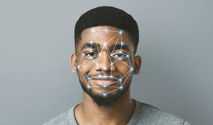

Figure 5.2.1 Facial Points Detection

**face_recognition** is a python library that builds on top of many libraries like Dlib library which is a modern C++ toolkit containing machine learning algorithms and tools for creating complex software in C++ and other machine learning algorithms.

Since Every Machine Learning algorithm takes a dataset as input and learns from this data. The face recognition algorithm goes through the data and identifies patterns in the data. For instance, suppose we wish to identify whose face is present in a given image, there are multiple things we can look at as a pattern:

* Height/width of the face.
* Height and width may not be reliable since the image could be rescaled to a smaller face. However, even after rescaling, what remains unchanged are the ratios – the ratio of height of the face to the width of the face won’t change.
* Color of the face.
* Width of other parts of the face like lips, nose, etc.

Clearly, there is a pattern here – different faces have different dimensions like the ones above. Similar faces have similar dimensions.

As a simple example, we can map a “face” into a feature vector which can comprise various features like:

* Height of face (cm)
* Width of face (cm)
* Average color of face (R, G, B)
* Width of lips (cm)
* Height of nose (cm)

Essentially, given an image, we can map out various features and convert it into a feature vector like:

|  |  |  |  |  |
| --- | --- | --- | --- | --- |
| **Height of face (cm)** | **Width of face (cm)** | **Average color of face (RGB)** | **Width of lips (cm)** | **Height of nose (cm)** |
| 23.1 | 15.8 | (255, 224, 189) | 5.2 | 4.4 |

So, our image is now a vector that could be represented as (23.1, 15.8, 255, 224, 189, 5.2, 4.4). Of course there could be countless other features that could be derived from the image (for instance, hair color, facial hair, spectacles, etc). However, for the example, let us consider just these 5 simple features.

Now, once we have encoded each image into a feature vector, the problem becomes much simpler. Clearly, when we have 2 faces (images) that represent the same person, the feature vectors derived will be quite similar. Put it the other way, the “distance” between the 2 feature vectors will be quite small.

The above algorithm that is Face Recognition Algorithm can help us here with two things:

1. **Deriving the feature vector:** it is difficult to manually list down all of the features because there are just so many. A Machine Learning algorithm can intelligently label out many of such features. For instance, a complex feature could be: ratio of height of nose and width of forehead. Now it will be quite difficult for a human to list down all such “second order” features.
2. **Matching algorithms:** Once the feature vectors have been obtained, a Machine Learning algorithm needs to match a new image with the set of feature vectors present in the corpus. Faces of the each students in different position needs to be feeded in to the database and the by applying the face recognition algorithm the encoding of all the students is to be stored and whenever the student is in the class the photo of the students is given to the system then the encodings of the known face and unknown face is to be matched and if matches then the attendance of the students is marked.

**5.2.1. DETERMINED SYSTEM:**

The task of the system is to capture the face of each student and encoding of each student needs to store it in the database.

when the attendance of the students is to be taken, each and every student needs to be sit properly in the classroom whenever the teacher takes the photo of students so that the encodings of the each and every student is to be extracted properly and will give to the system then the encodings of the known images and the unknown images is to be matched and thus the marking of the attendance is to be done.

**5.3 Datasets Source and Utilization**

The images of the students in the database with the name of the image is the full name of the student so that in case there might be 2 students having the same name so to avoid such confusion the name of the image which needs to be store in to the database is having the different name also the database size must be enough and good also the images which will be saved in the database must be having the dimensions of less than 700 X 700 and the size of the image is less than 600kb. The next step of working is to extract the encodings from the images present in the database and saving the encodings in to the pickle file this is because we are extracting the images encodings in the form of dictionary having the key as the name of the image for which the encodings are to be generated and the values as the list which contains the encodings of the each images.

**Images In Database:**

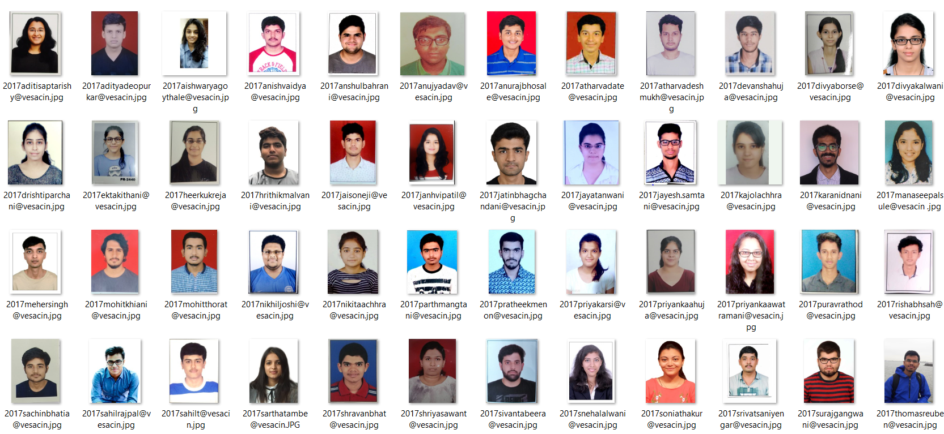

Figure 5.3.1-dataset 1

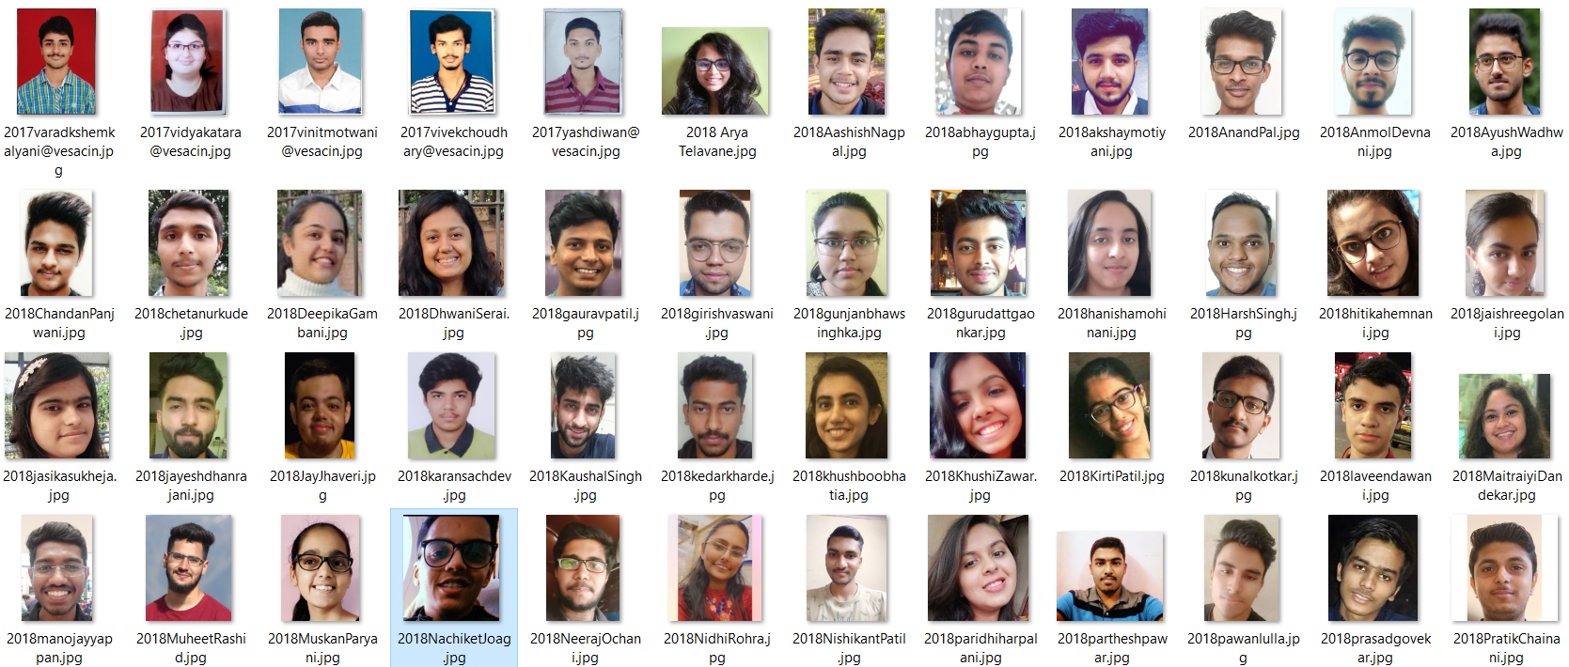

Figure 5.3.2-dataset 2

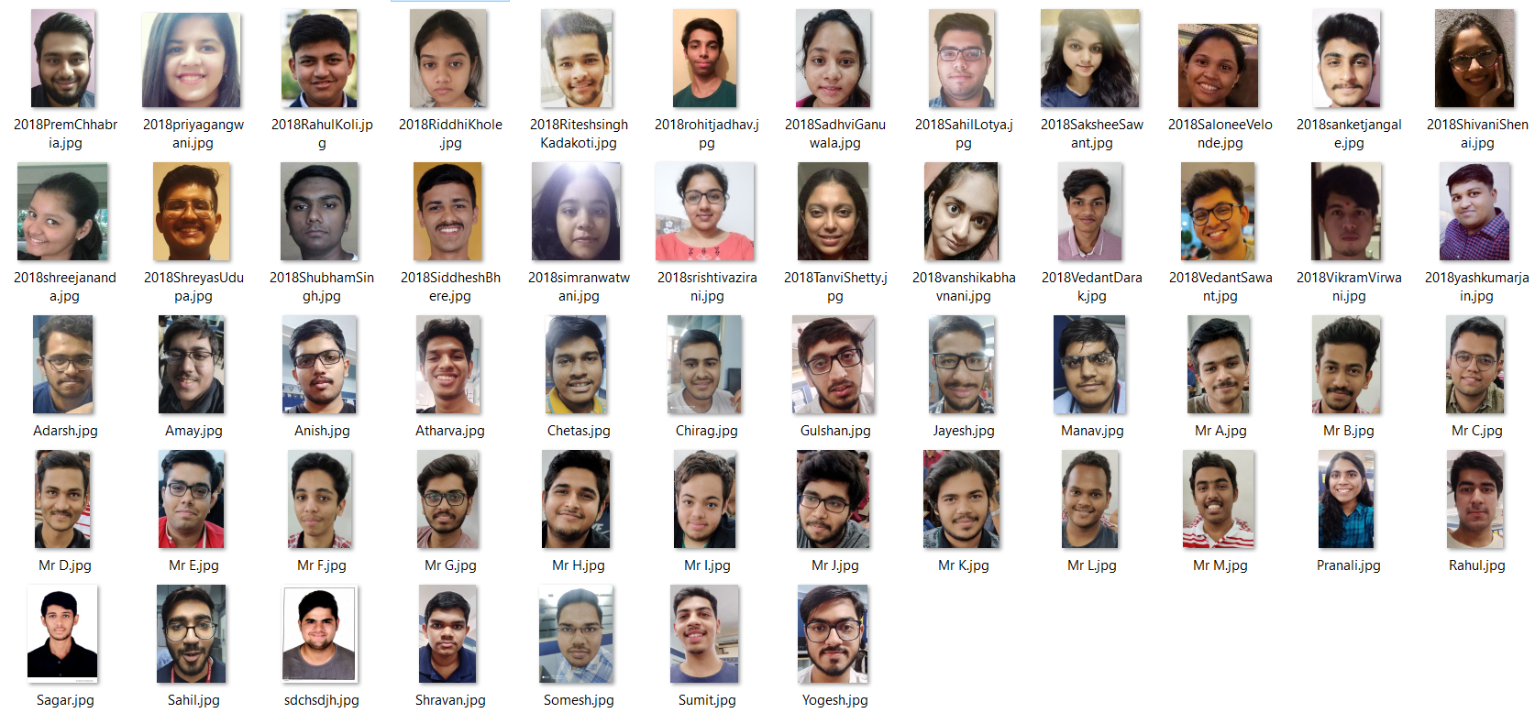

Figure 5.3.3-dataset 3

**5.4. Screenshots (GUI) of the project**

**Attendance By Image Upload Page:**

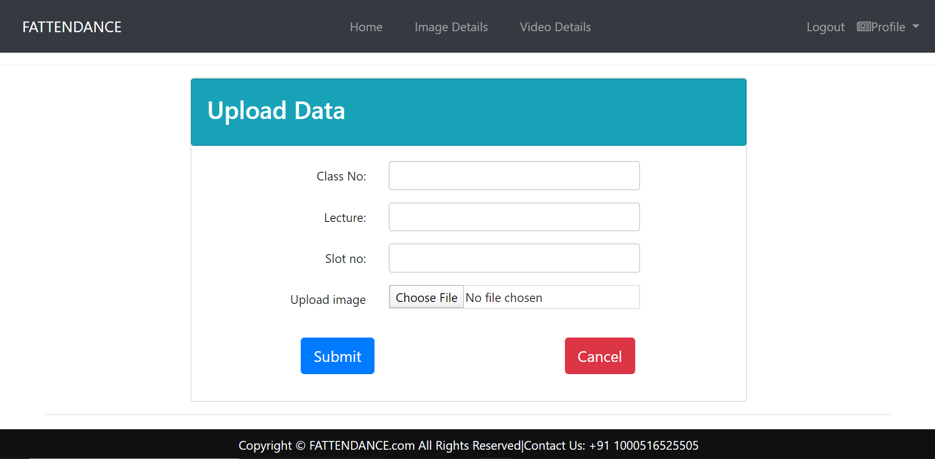

Figure 5.4.1-Attendance by Image Upload

**Image Details Page:**

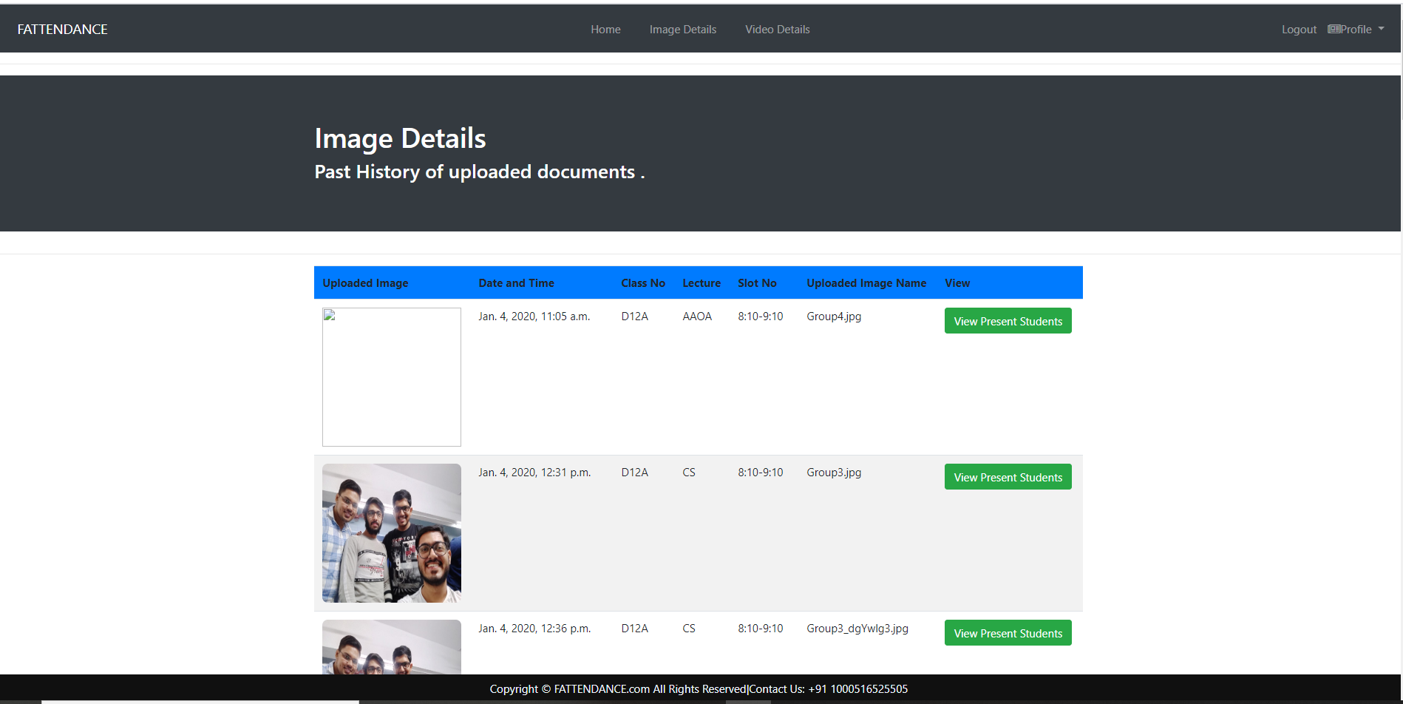

Figure 5.4.2-Image Details

**Image Details of Students Present Page:**

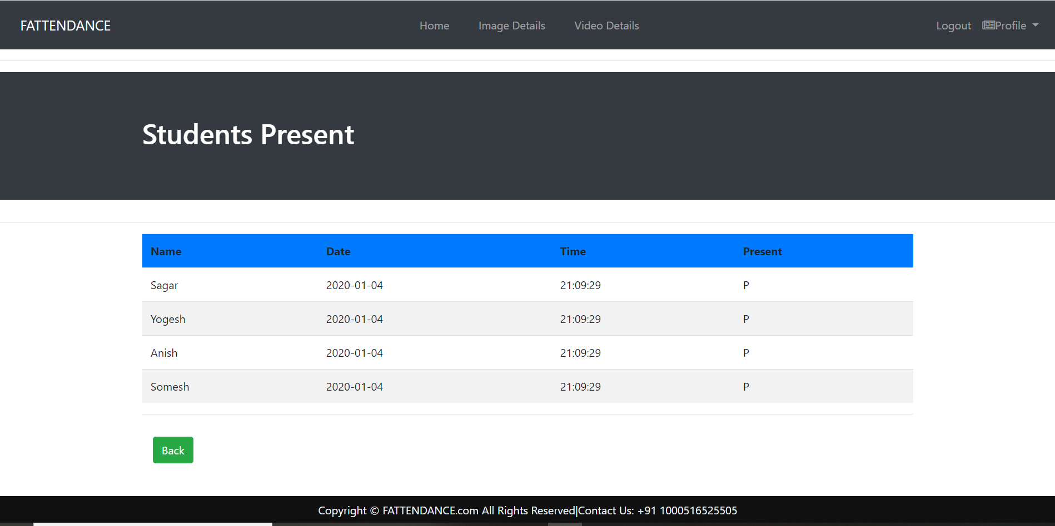

Figure 5.4.3-Image Details of Students Present

**Attendance By Video Upload Page:**

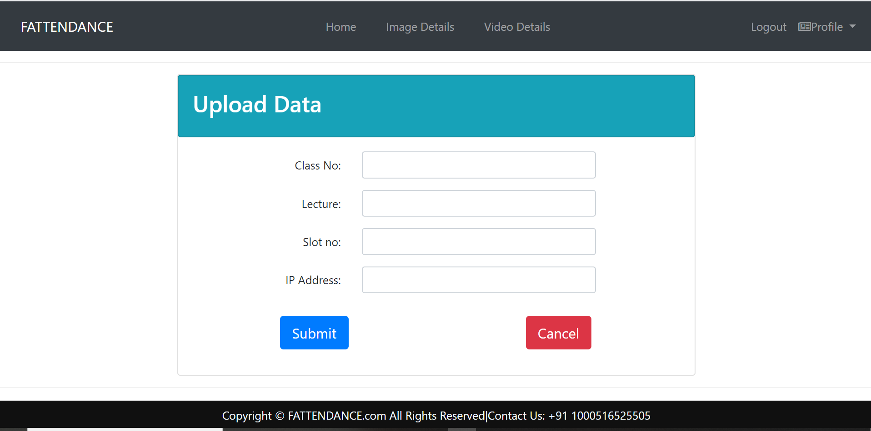

Figure 5.4.4-Attendance by Video Upload

**Video Details Page:**

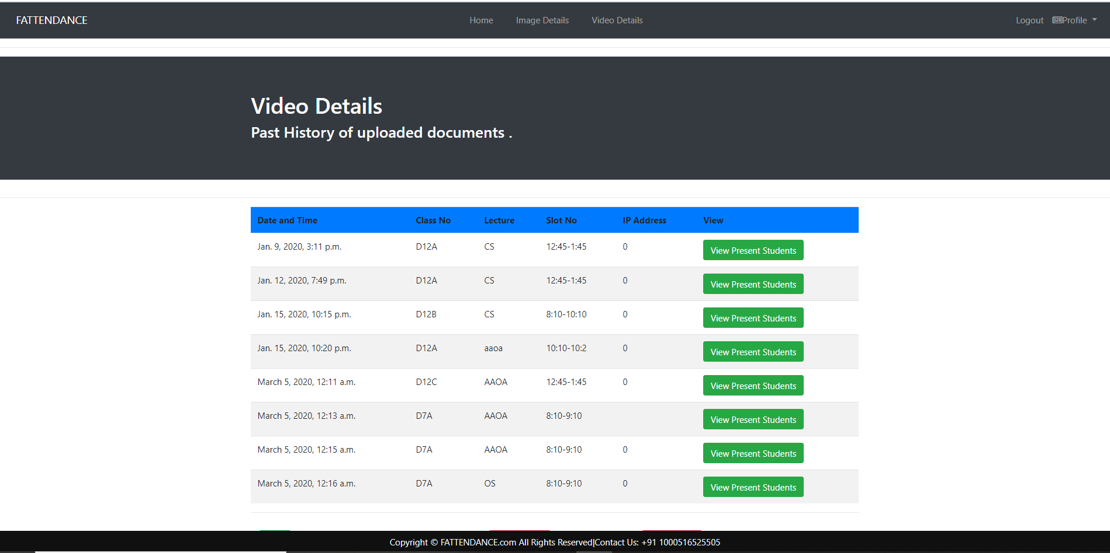

Figure 5.4.5-Video Details

**Video Details of Students Present Page:**

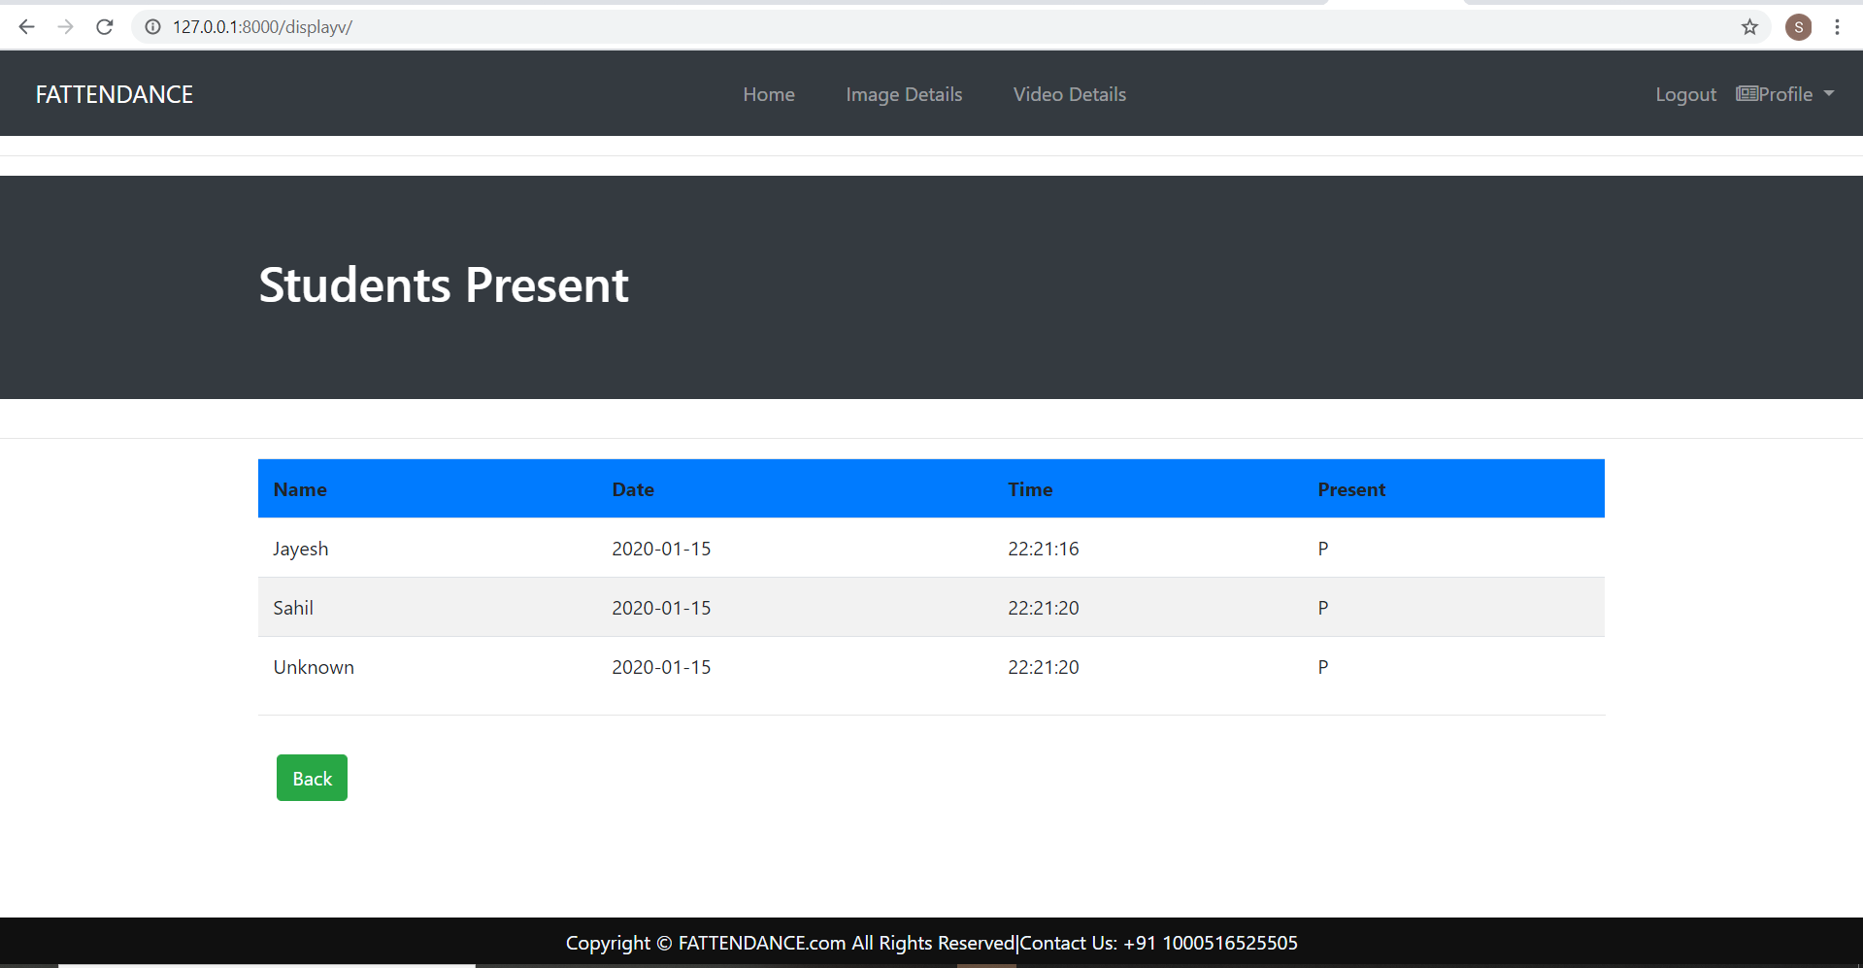

Figure 5.4.6- Video Details of Students Present

**Chapter 6: TESTING**

**6.1. Definition of Test Case**

A test case is a set of conditions or variables under which a tester will determine whether a system under test satisfies requirements or works correctly. The process of developing test cases can also help find problems in the requirements or design of an application.

**6.2. Types of Test Cases**

**6.2.1 Black Box Testing**

Black-box testing is a method of software testing that examines the functionality of an application (e.g. what the software does) without peering into its internal structures or workings (see white-box testing).

**6.2.2 White Box Testing**

White-box testing (also known as clear box testing, glass box testing, transparent box testing, and structural testing) is a method of testing software that tests internal structures or workings of an application, as opposed to its functionality (i.e. black-box testing). In white-box testing an internal perspective of the system, as well as programming skills, are used to design test cases.

**6.2.3 Unit Testing**

Unit testing, also known as component testing, refers to tests that verify the functionality of a specific section of code, usually at the function level. In an object-oriented environment, this is usually at the class level, and the minimal unit tests include the constructors and destructors. These types of tests are usually written by developers as they work on code (white-box style), to ensure that the specific function is working as expected.

**6.2.4 Integration Testing**

Integration testing is any type of software testing that seeks to verify the interfaces between components against a software design. Software components may be integrated in an iterative way or all together ("big bang").

**6.2.5 Component Interface Testing**

The practice of component interface testing can be used to check the handling of data passed between various units, or subsystem components, beyond full integration testing between those units. The data being passed can be considered as "message packets" and the range or data types can be checked, for data generated from one unit, and tested for validity before being passed into another unit.

**6.2.6 System Testing**

System testing, or end-to-end testing, tests a completely integrated system to verify that it meets its requirements. For example, a system test might involve testing a login interface, then creating and editing an entry, plus sending or printing results, followed by summary processing or deletion (or archiving) of entries, then logoff. In addition, the software testing should ensure that the program, as well as working as expected, does not also destroy or partially corrupt its operating environment or cause other processes within that environment to become inoperative (this includes not corrupting shared memory, not consuming or locking up excessive resources and leaving any parallel processes unharmed by its presence).

**6.2.7 Alpha Testing**

Alpha testing is a type of acceptance testing; performed to identify all possible issues/bugs before releasing the product to everyday users or the public. The focus of this testing is to simulate real users by using black box and white box techniques. The aim is to carry out the tasks that a typical user might perform. Alpha testing is carried out in a lab environment and usually the testers are internal employees of the organization. To put it as simple as possible, this kind of testing is called alpha only because it is done early on, near the end of the development of the software, and before beta testing.

**6.2.8 Beta Testing**

Beta Testing of a product is performed by "real users" of the software application in a "real environment" and can be considered as a form of external user acceptance testing. Beta version of the software is released to a limited number of end-users of the product to obtain feedback on the product quality.

**6.3. Test Cases**

**1) SYSTEM TESTING**

|  |  |  |  |  |  |  |
| --- | --- | --- | --- | --- | --- | --- |
| **Case No.** | **No of Students Present In Image** | **No of Face Visible in the Image** | **No of Faces**  **Detected** | **No of Faces**  **Recognize Correctly** | **No of Faces**  **Recognized**  **Incorrectly** | **Accuracy**  **(in %)** |
| 1. | 2 | 2 | 2 | 2 | 0 | 100 |
| 2. | 4 | 4 | 4 | 4 | 0 | 100 |
| 3. | 5 | 5 | 5 | 5 | 0 | 100 |
| 4. | 7 | 7 | 7 | 7 | 0 | 100 |
| 5. | 9 | 9 | 9 | 9 | 0 | 100 |
| 6 | 10 | 9 | 9 | 9 | 0 | 100 |
| 7 | 20 | 19 | 18 | 17 | 1 | 89.47 |
| 8 | 30 | 28 | 25 | 22 | 3 | 78.5 |
| 9 | 53 | 48 | 46 | 39 | 7 | 81.25 |

**Output For Case 4:** Total no of Students 7/7 Detected and Recognized Successfully

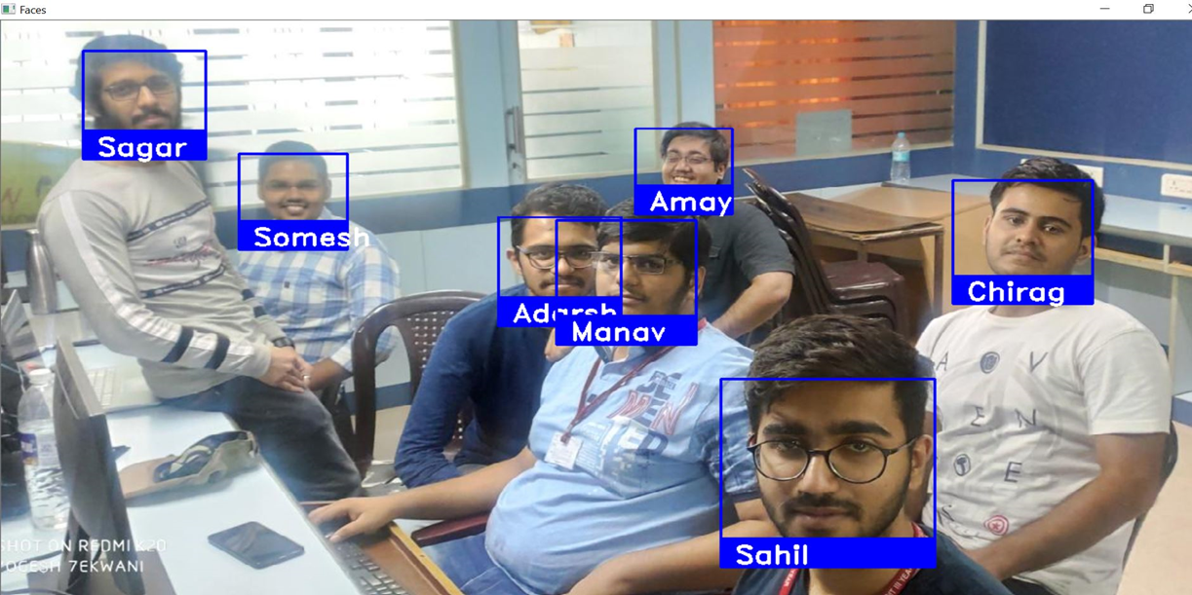

Fig-6.3.1- Recognized Image-1

**Output For Case 5 :**Total no of Students 10 out of which 9 Detected and Recognized Successfully

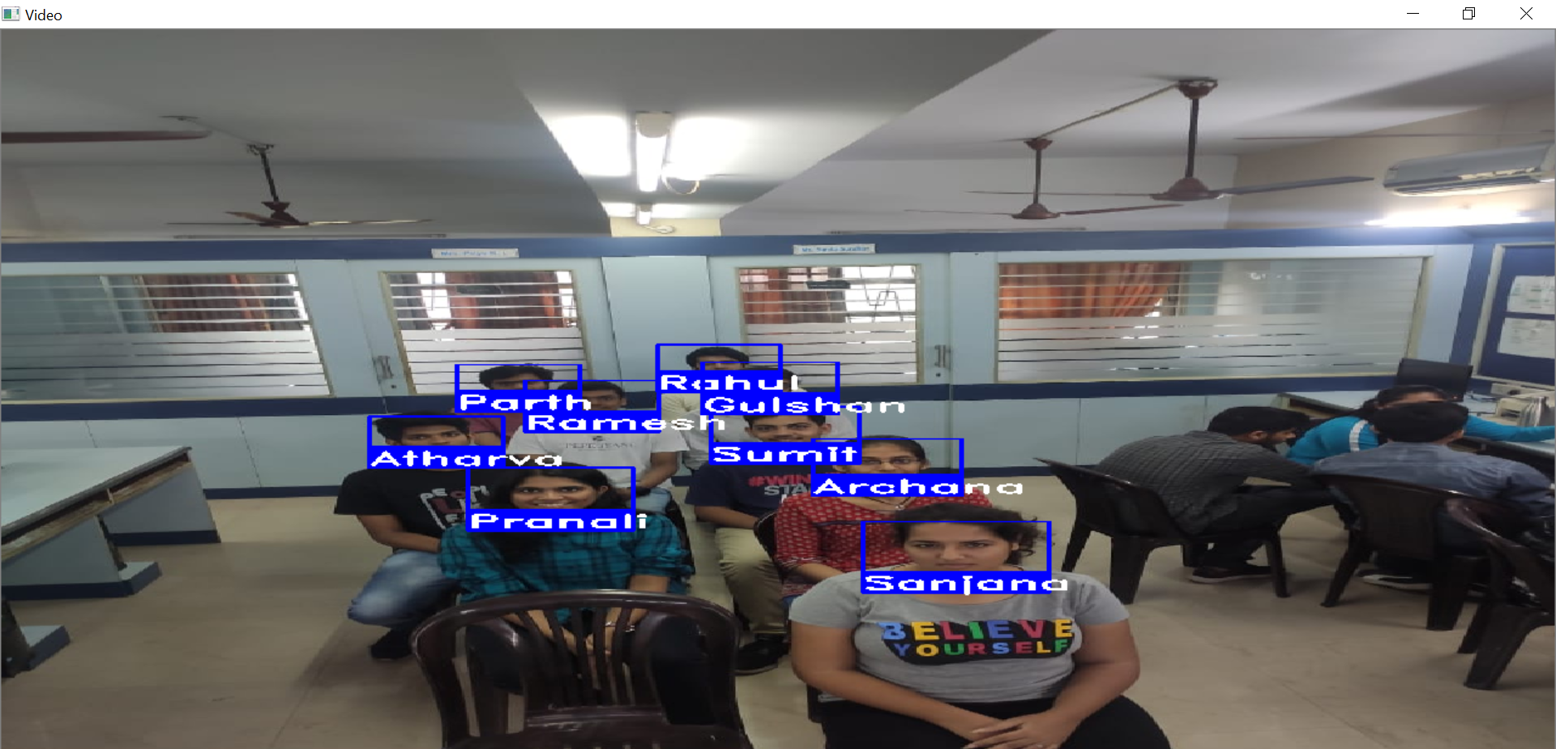

Fig-6.3.3-Recognized Image-2

**Output For Case 6 :**Total no of Students 10 out of which 9 Detected and Recognized Successfully

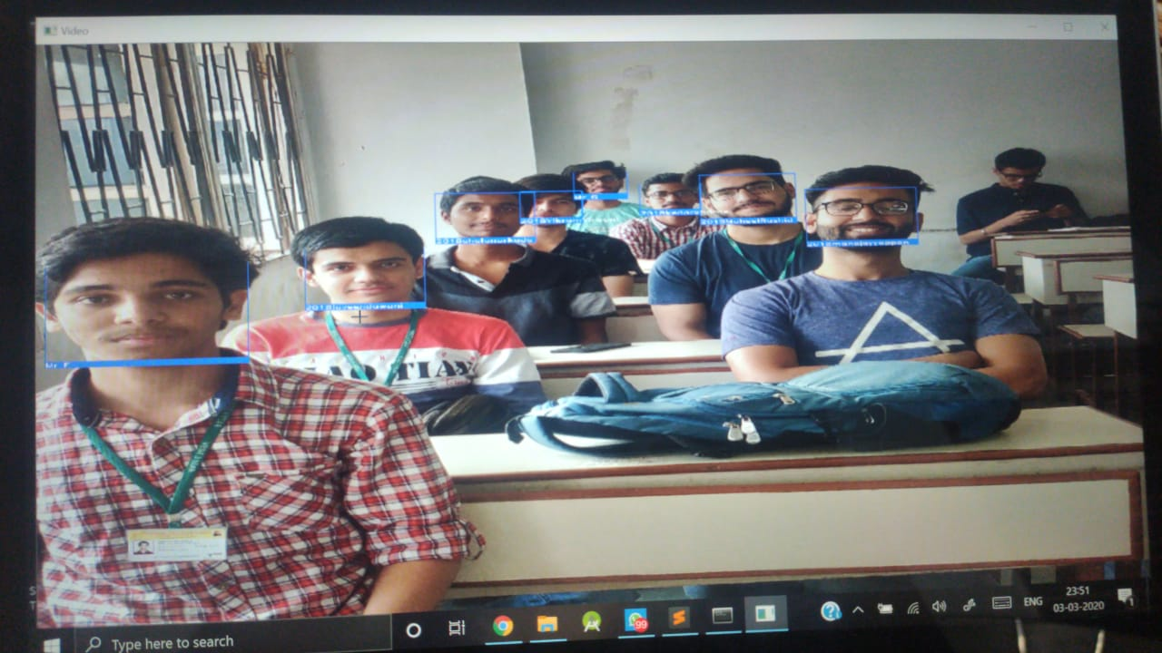

Fig-6.3.3-Recognized Image-3

**6.4. Test Results**

**Case1:**

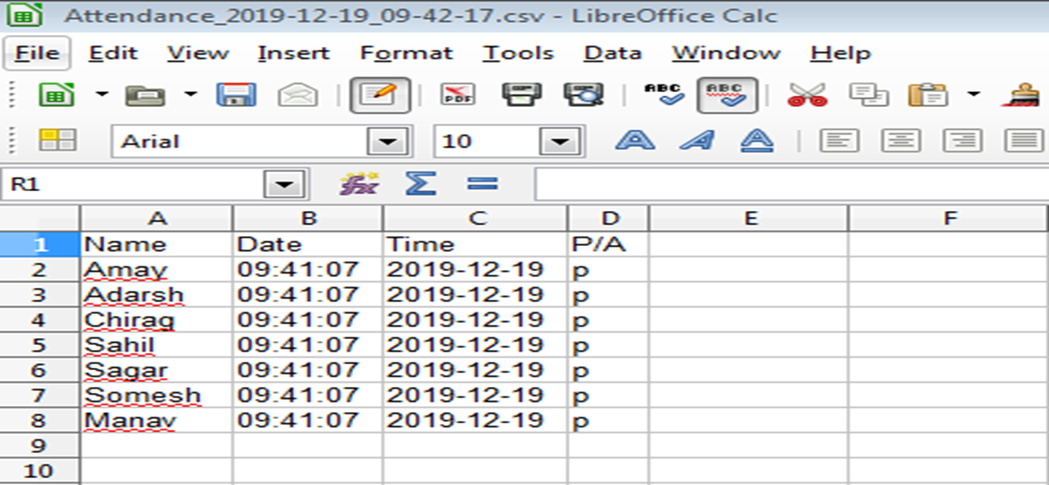

Fig-6.4.1-Case1 Attendendance Sheet 1

**Case2:**

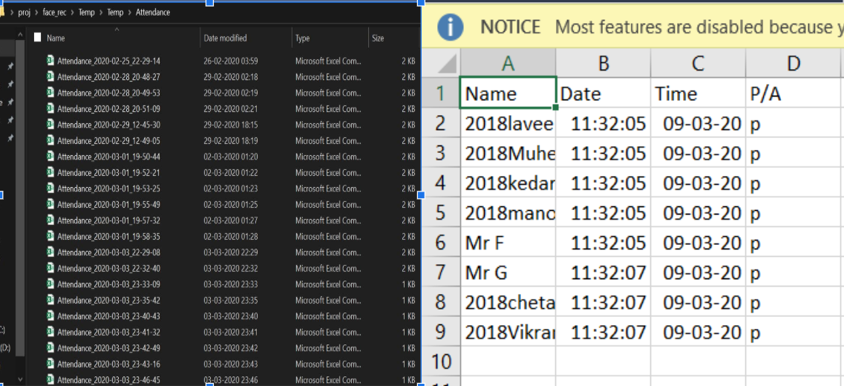

Fig-6.4.2-Case2 Attendendance Sheet 2

**Chapter 7: RESULT ANALYSIS**

**7.1 Evaluation Measures**

**Case1:** TOTAL IMAGES IN THE DATASET : 40

**Output Accuracy** :

1. 7 out of 7 recognized. ( avg > 90% )
2. 9 out of 9 recognized. (avg >90% )

**Case2:** TOTAL IMAGES IN THE DATASET : 150

**Output Accuracy :**

1. 9 out of 9 recognized. ( >90% )
2. 8 out of 8 recognized. ( >90% )

**7.2 Input Parameters Considered**

* The Camera used should be able to capture images with Maximum Resolution and High Picture Quality. { Higher the Resolution, Higher is the Accuracy. }
* Network connectivity (Wi-Fi) should be fast and stable enough throughout the entire process to ensure minimum errors.
* Faces should be properly visible to the Camera ( visibility > 50%).
* Faces not present/ Unmatched faces are by default marked as “Unknown”.

**7.3 Comparison of results with existing system**

* The Database used is of the Colored Images of the Student with different angle as compared to the black and white images
* Processing time is less in our system as compared to the system which uses an external hardware (eg-Wires)
* The chances of spoofing the face recognition system are reduced
* Our Software is Feasible and Efficient as compared to other system

**8. CONCLUSION**

**8.1 Limitations**

The automated attendance system can be implemented in larger areas like in a seminar hall where it helps in sensing the presence of many people. Sometimes the poor lighting condition of the classroom may affect image quality which indirectly degrades system performance, this can be overcome in the latter stage by improving the quality of the video or by using some algorithm.

**8.2 Conclusion**

* Thus, our solution for Intelligent Attendance successfully minimizes Human-Interference, Enhances transparency and completely eliminates the Gaps of the current system.
* The Automation helps in eliminating the Fraudulent entries and ultimately achieve the High-precision, Real-Time attendance to meet the need for Automatic and Reliable evaluation.

**8.3 Future Scope**

* Currently, we have designed a system that detects the presence of a person by using Real-Time Face Recognition from a Real-Time Camera (eg: Photo).
* Also, we are strategizing to detect and store the Unknown faces as well for further evaluations.
* Since, the base model is in working condition, we have received many useful suggestions to build multiple UIs for Gyms, Classrooms, Playschools, Security Alarms, ATMs, Seminar Halls, CCTV Footage Scanners, etc.

**References**

[1] Samuel Lukas, Aditya Rama Mitra, Ririn Ikana Desanti, Dion Krisnadi, "Student Attendance System in Classroom Using Face Recognition Technique", Conference Paper DOI: 10.1109/ICTC.2016.7763360, Oct 2016.

[2]Face Recognition Based on HOG and Fast PCA Algorithm Xiang-Yu Li(&) and Zhen-Xian Lin International Research Journal of Engineering and Technology (IRJET) e-ISSN: 2395-0056 Volume: 05 Issue: 04 | Apr-2018 www.irjet.net p-ISSN: 2395-0072 © 2018, IRJET | Impact Factor value: 6.171 | ISO 9001:2008 Certified Journal | Page 4610

[3]Attendance System Using Face Recognition and Class Monitoring System, Arun Katara1, Mr. Sudesh2, V.Kolhe3http://www.ijritcc.org/download/browse/Volume_5_Issues/February_17_Volume_5_Issue_2/1489565866_ 15- 03-2017.pdf

[4] N.Sudhakar Reddy, M.V.Sumanth, S.Suresh Babu, "A Counterpart Approach to Attendance and Feedback System using Machine Learning Techniques",Journal of Emerging Technologies and Innovative Research (JETIR), Volume 5, Issue 12, Dec 2018.

[5] Dan Wang, Rong Fu, Zuying Luo, "Classroom Attendance Auto-management Based on Deep Learning",Advances in Social Science, Education and Humanities Research, volume 123,ICESAME 2017

[6] Akshara Jadhav, Akshay Jadhav, Tushar Ladhe, Krishna Yeolekar, "Automated Attendance System Using Face Recognition", International Research Journal of Engine

[7] B Prabhavathi, V Tanuja, V Madhu Viswanatham and M Rajashekhara Babu, "A smart technique for attendance system to recognize faces through parallelism", IOP Conf. Series: Materials Science and Engineering 263, 2017.

[8] Prajakta Lad, Sonali More, Simran Parkhe, Priyanka Nikam, Dipalee Chaudhari, " Student Attendance System Using Iris Detection", IJARIIE-ISSN(O)-2395-4396, Vol-3 Issue-2 2017.

[9] M. H. Muchri, S. Lukas, and D. H. Hareva, “Implementation discrete cosine transform and radial basis function neural network in facial image recognition,” in Proc. International Conference on Soft Computing Intelligent Systems, and Information Technology, 2015

[10] D. Gupta and S. Choubey, “Discrete wavelet transform for image processing,” International Journal of Emerging Technology and Advanced Engineering, vol. 4, issue 3, March, 2015.

**Appendix**

1. **Progress Review Sheet 1 -**

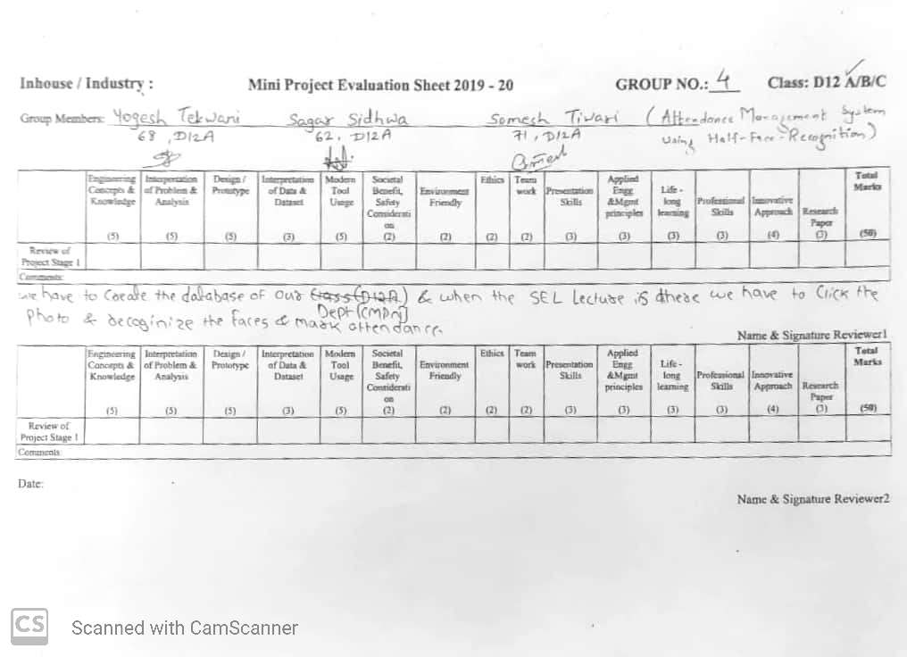

**REPRESENTED OUR COLLEGE IN RESEARCH COMPETITION AVISHKAR**

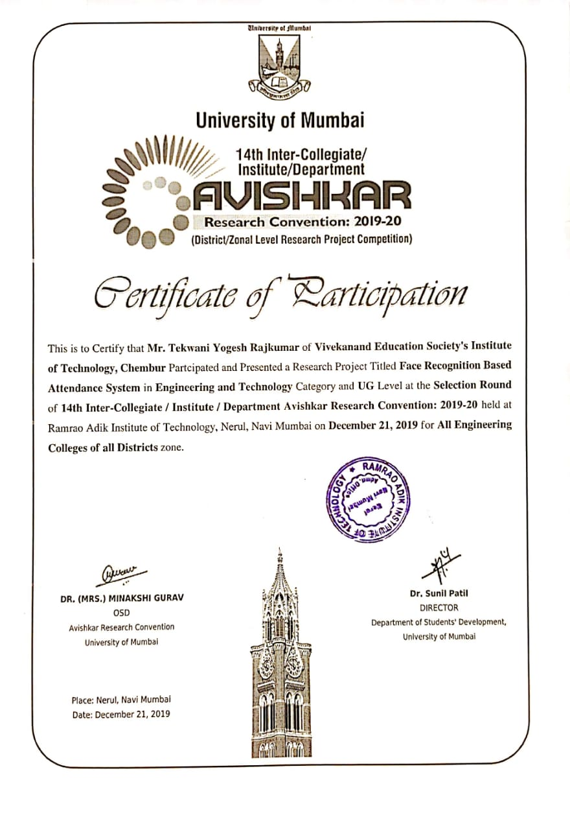

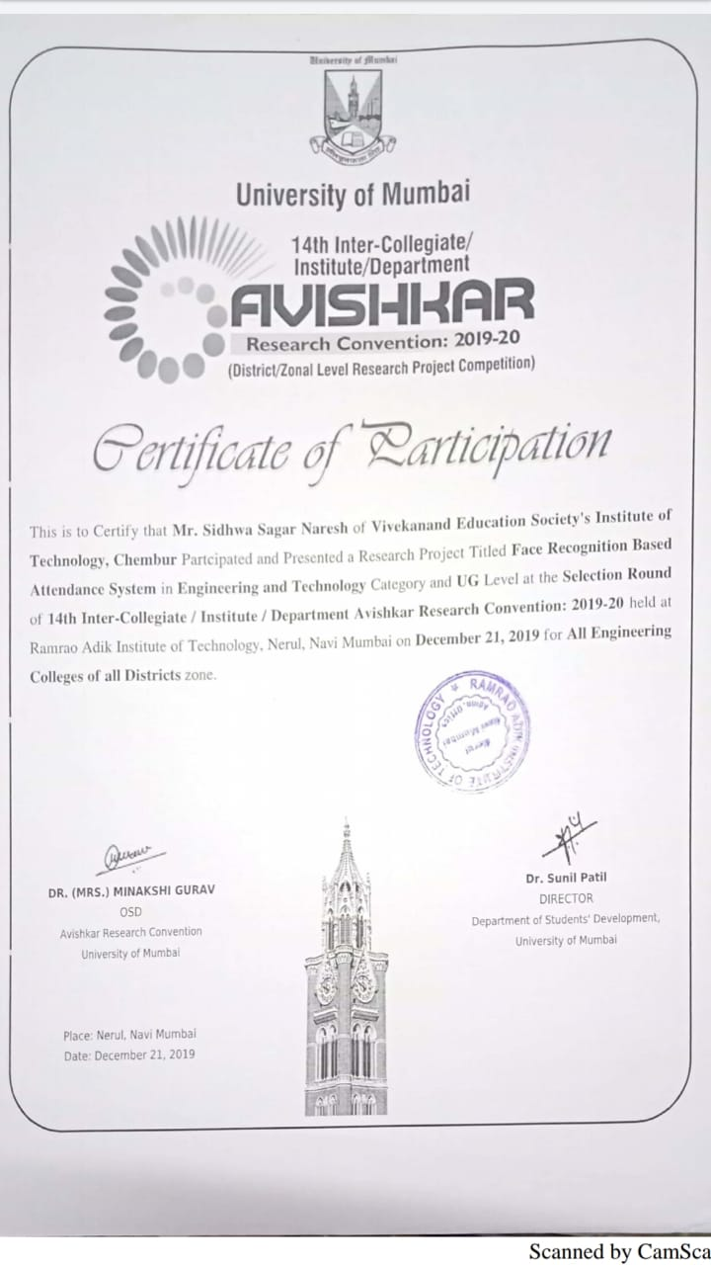

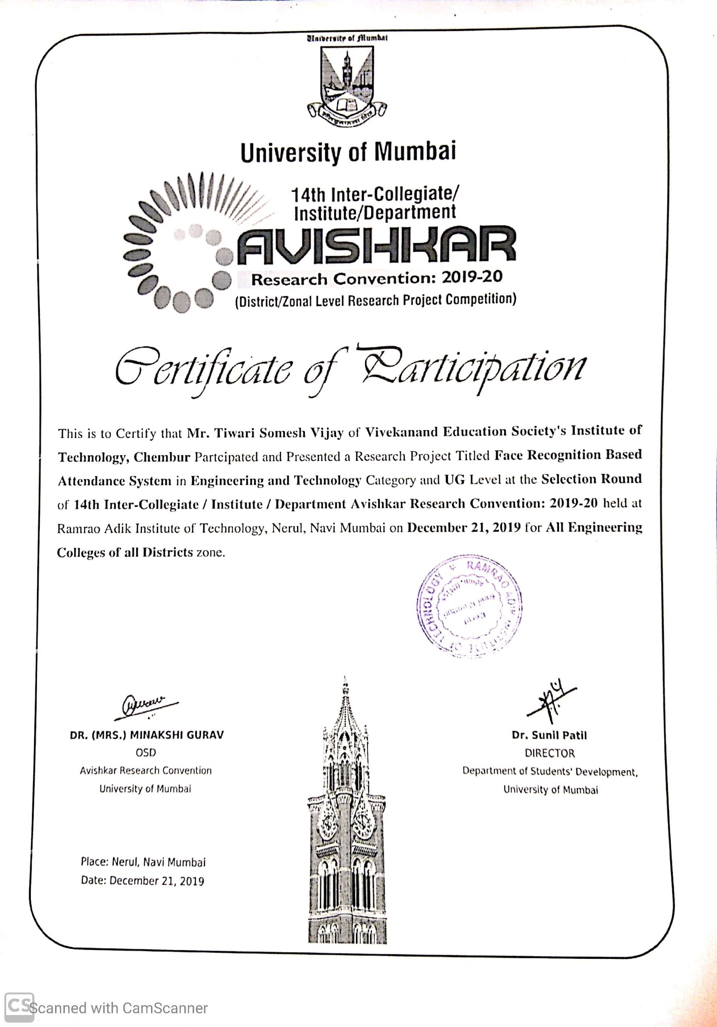

**This project has received the Research Grant by our college(VESIT).**

